Table 1. Geometrical characteristics of the analysed models of stiffened plates.

Type | Model | Shape | h_{w} | t_{w} | b_{f} | t_{f} | I [cm⁴] | q [kg/m]* | Z_{min} [cm³]*
1 | F1 | flat | 177 | 14 | - | - | 647 | 101.1 | 149
1 | T1 | tee | 150 | 9 | 90 | 12 | 648 | 100.7 | 213
1 | A1 | angle | 150 | 9 | 90 | 12 | 648 | 100.7 | 213
2 | F2 | flat | 270 | 17 | - | - | 2,788 | 117.7 | 394
2 | T2 | tee | 250 | 10 | 90 | 15 | 2,844 | 111.9 | 526
2 | A2 | angle | 250 | 10 | 90 | 15 | 2,844 | 111.9 | 526
3 | F3 | flat | 445 | 16 | - | - | 11,749 | 137.5 | 947
3 | T3 | tee | 400 | 12 | 100 | 17 | 11,860 | 132.7 | 1,211
3 | A3 | angle | 400 | 12 | 100 | 17 | 11,860 | 132.7 | 1,211
* Z_{min} includes width 800 mm of the plate having thickness of 13 mm

Table 2. Coefficients of thin-horse mode initial deflection as a function of plate aspect ratio [19].

a/a/b | A01/t | A02/t | A03/t | A04/t | A05/t | A06/t | A07/t | A08/t | A09/t | A010/t | A011/t
 | 1.1158 | -0.0276 | 0.1377 | 0.0025 | -0.0123 | -0.0009 | -0.0043 | 0.0008 | 0.0039 | -0.0002 | -0.0011
 | 1.1421 | -0.0457 | 0.2284 | 0.0065 | 0.0326 | -0.0022 | -0.0109 | 0.001 | -0.0049 | -0.0005 | 0.0027
 | 1.1458 | -0.0616 | 0.3079 | 0.0229 | 0.1146 | -0.0065 | 0.0327 | 0.000 | 0.000 | -0.0015 | -0.0074
 | 1.1439 | -0.0677 | 0.3385 | 0.0316 | 0.1579 | -0.0149 | 0.0743 | 0.0059 | 0.0293 | -0.0012 | 0.0062
 | 1.1271 | -0.0697 | 0.3483 | 0.0375 | 0.1787 | -0.0199 | 0.0995 | 0.0107 | 0.0537 | -0.0051 | 0.0256

Table 3. Geometric and material properties of Tanaka & Endo tests.
Structure No. | L (mm) | b (mm) | t  (mm) | $h_{w}$ (mm) | $$t_{w}$$  (mm) | $$\frac{h_{w}}{t_{w}}$$ | $$A_{\text{03}}$$  (mm) | $σ_{\text{Yp}}$ (MPa) | $$σ_{\text{Ys}}$$  (MPa) | $$E$$  (GPa)
D0 |  | 1440 | 6.15 | 110.0 | 9.77 | 11.26 | 0.101 | 234.2 | 287.1 | 205.8
D0A |  | 1440 | 5.65 | 110.0 | 10.15 | 10.84 | 0.250 | 249.9 | 196.0 | 205.8
D1 |  | 1200 | 5.95 | 110.0 | 10.19 | 10.79 | 0.143 | 253.8 | 250.9 | 205.8
D2 |  | 1560 | 5.95 | 110.0 | 10.19 | 10.79 | 0.288 | 253.8 | 250.9 | 205.8
D3 | 1080 | 1440 | 5.95 | 103.5 | 11.84 | 8.74 | 0.312 | 253.8 | 326.3 | 205.8
D4 |  | 1440 | 5.95 | 118.5 | 7.98 | 14.85 | 0.119 | 253.8 | 284.2 | 205.8
D4A |  | 1440 | 5.65 | 118.5 | 8.08 | 14.67 | 0.379 | 249.9 | 274.4 | 205.8
D10 |  | 1200 | 4.38 | 65.0 | 4.38 | 14.84 | 0.515 | 442.0 | 442.0 | 205.8
D11 |  | 1200 | 4.38 | 90.0 | 4.38 | 20.55 | 0.503 | 442.0 | 442.0 | 205.8
D12 |  | 1440 | 4.38 | 65.0 | 4.38 | 14.84 | 0.523 | 442.0 | 442.0 | 205.8

Table 4. Summary of results for some of Tanaka & Endo tests.
Structure No. | Tanaka & Endo | Present
Structure No. | $$\frac{(σ_{\text{Ult}})_{\text{FEM}}}{(σ_{\text{Ult}})_{\text{EXPERIMENT}}}$$ | $$\frac{(σ_{\text{Ult}})_{\text{FEM}}}{(σ_{\text{Ult}})_{\text{EXPERIMENT}}}$$ | Collapse mode
D0 | 0.977 | 1.014 | 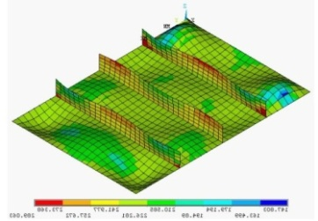
D0A | 1.028 | 1.065 | 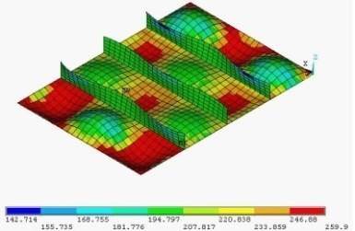
D1 | 0.869 | 0.911 | 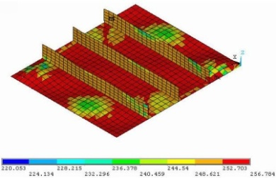
D2 | 0.936 | 0.944 | 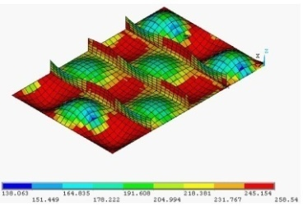
D3 | 0.860 | 0.853 | 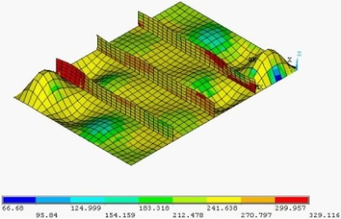
D4 | 0.792 | 0.866 | 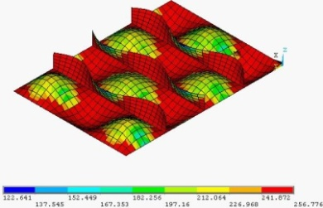
D4A | 0.866 | 0.960 | 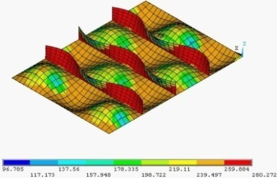

Table 5. Deformation mode and spread of plasticity for the plate of dimensions 1600×800×14 mm (AR=2) with 5-20 years exposure (magnification factor for deformation mode: 10).

Case | Ultimate strength level | Final step
Uncorroded  t = 14 mm | 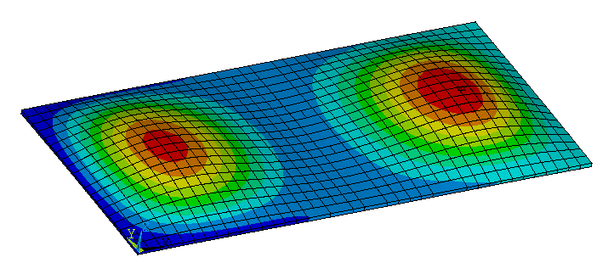 | 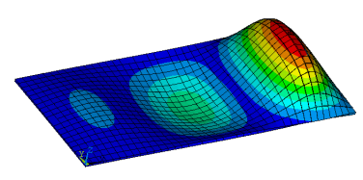
5-year  t = 13.17 mm | 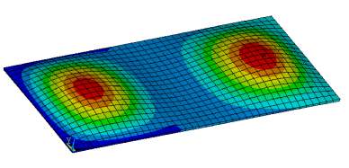 | 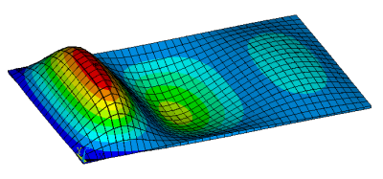
10-year  t = 11.73 mm | 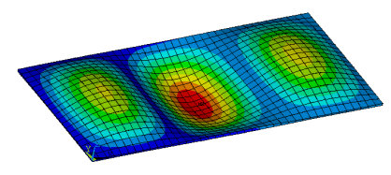 | 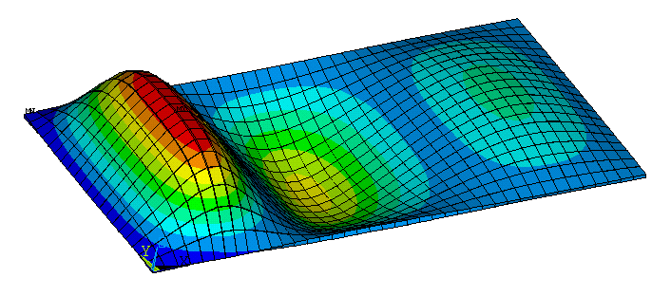
15-year  t = 9.94 mm | 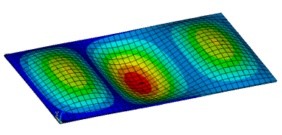 | 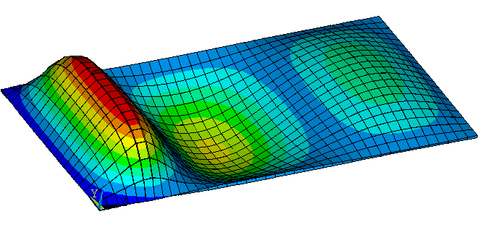
20-year  t = 8.18 mm | 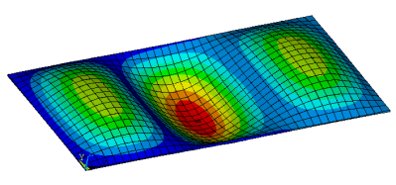 | 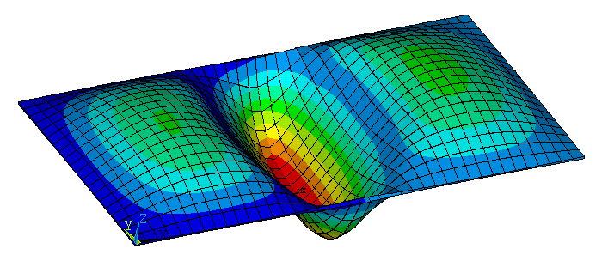

Table 6. Deformation mode and spread of plasticity for the plate of dimensions 2400×800×14 mm (AR=3) with 5-20 years exposure (magnification factor for deformation mode: 10).

Case | Ultimate strength level | Final step
Uncorroded  t = 14 mm | 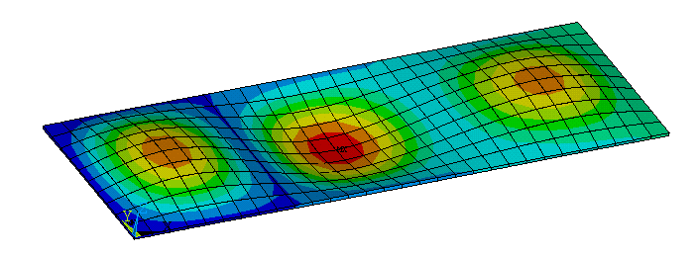 | 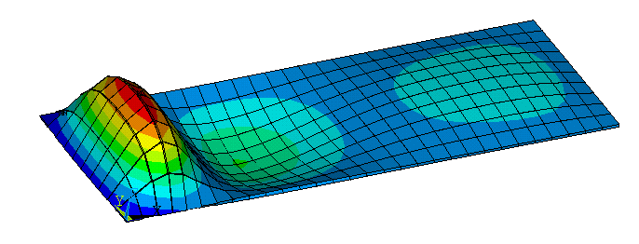
5-year  t = 13.3 mm | 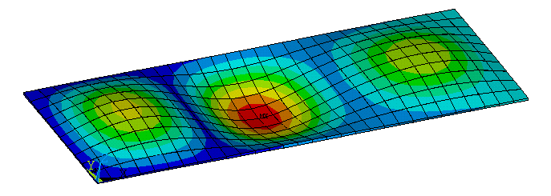 | 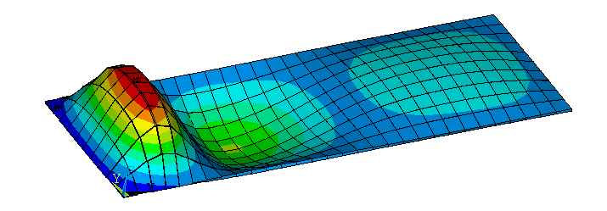
10-year  t = 11.75 mm | 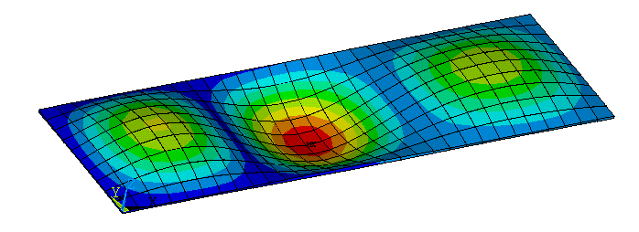 | 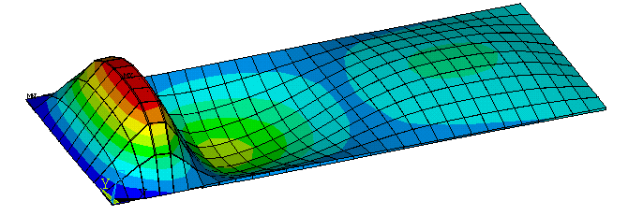
15-year  t = 10.04 mm | 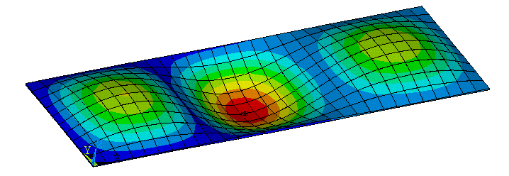 | 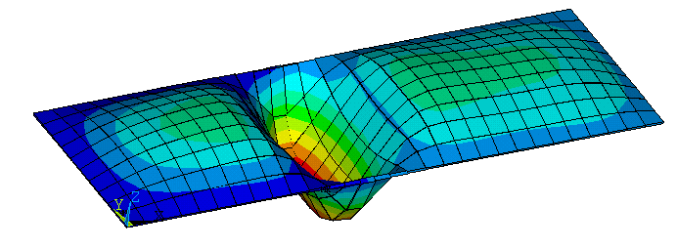
20-year  t = 8.23 mm | 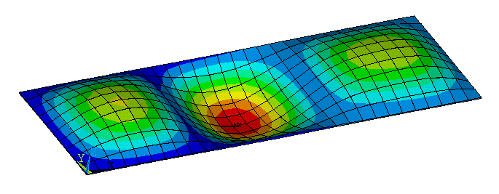 | 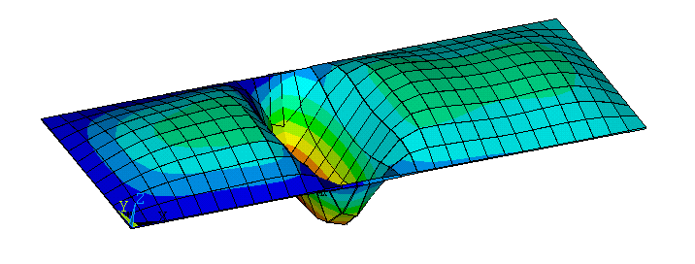

Table 7. Deformation mode and spread of plasticity for the plate of dimensions 1600×800×18 mm (AR=2) with 5-20 years exposure (magnification factor for deformation mode: 10).

Case | Ultimate strength level | Final step
Uncorroded  t = 18 mm | 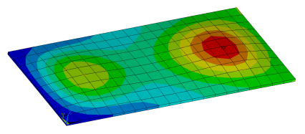 | 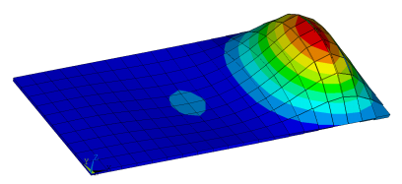
5-year  t = 17.47 mm | 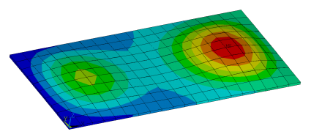 | 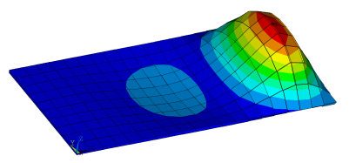
10-year  t = 15.50 mm | 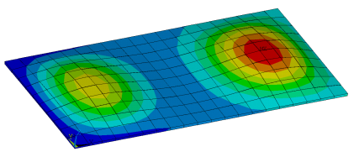 | 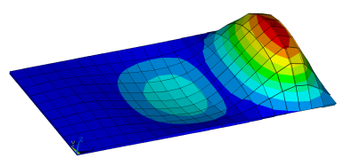
15-year  t = 13.79 mm | 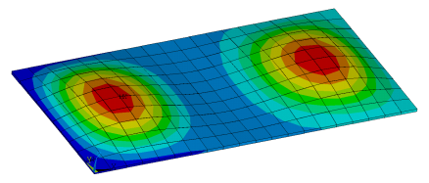 | 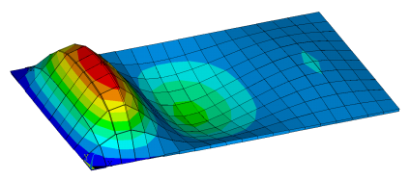
20-year  t = 12.43 mm | 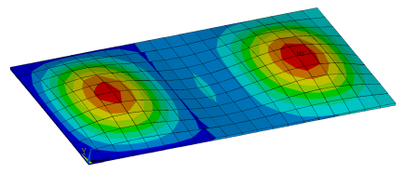 | 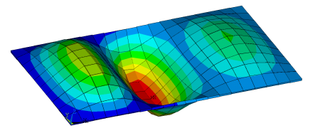

Table 8. Deformation mode and spread of plasticity for the plate of dimensions 2400×800×18 mm (AR=3) with 5-20 years exposure (magnification factor for deformation mode: 10).

Case | Ultimate strength level | Final step
Uncorroded  t = 18 mm | 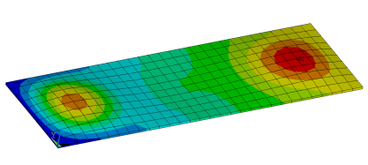 | 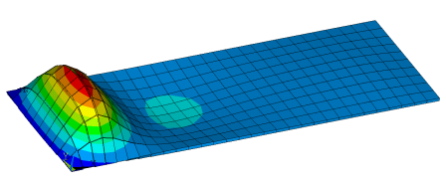
5-year  t = 17.47 mm | 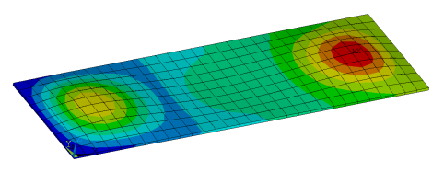 | 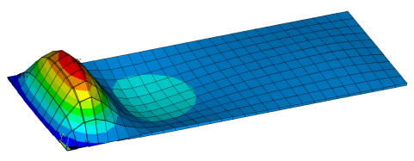
10-year  t = 15.50 mm | 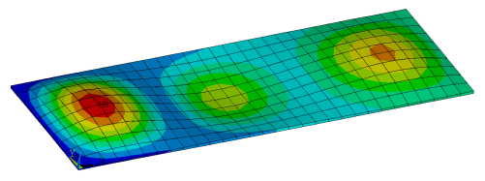 | 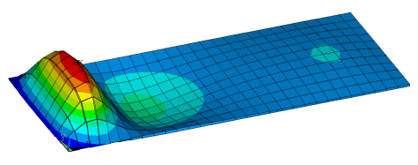
15-year  t = 13.79 mm | 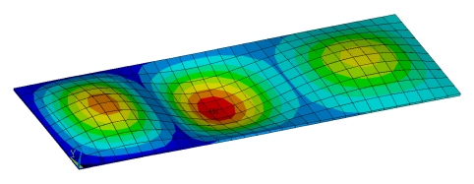 | 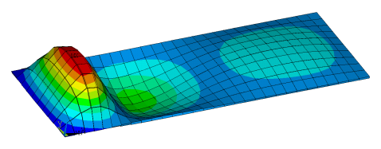
20-year  t = 12.43 mm | 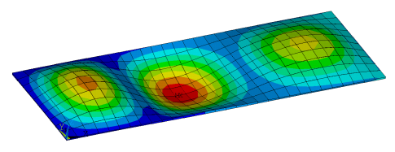 | 